Rotherfield Greys Parish meeting 9th March 2026
Drainage
I have raised two drainage issues and currently they are being priced and scheduled.
Church Close
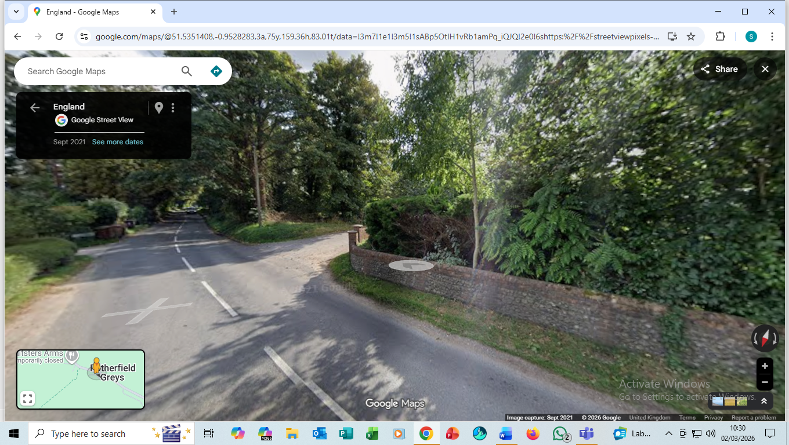
Corner towards Greys Near junction to Bix and Greys.
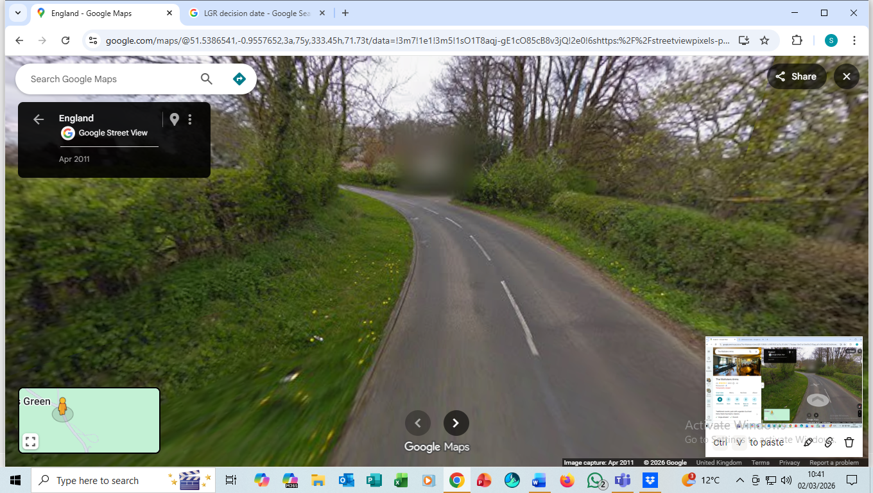
Meeting with OCC officers to discuss Chicanes 13th February and Annette.
We were unsuccessful in getting funding from Highlands Park to mitigate the excess traffic. Therefore, we are meeting with OCC officers to find out what is possible re traffic calming measures.
Fire Station
Henley Fire station is under threat of closure which will impact Henley and the surrounding villages. The consultation is closed and we await the outcome. We very successfully led a campaign which resulted in a meeting with 200 residents making it clear to Rob Macdougal Chief Fire Officer that closure of Henley is not an option.
Local Government reorganisation

This rumbles on and a decision will be made by Summer 26 with final submission in November. We wait and see. There are two proposals. Whole Oxfordshire and Ridgeway which is Vale, South Oxon and West Berkshire.

